** A**

**Project Report**

on

**PhobiaX: Revolutionizing Therapy with Virtual Reality**

submitted as partial fulfillment for the award of

**BACHELOR OF TECHNOLOGY**

**DEGREE**

SESSION 2024-25

in

**Computer Science and Information Technology**

By

Yadav Anurag Brijeshpratap(2100290110032)

Harsh Singh(2100290110061)

Khushboo Chaturvedi(2100290110074)

Shaiz Khan(2100290110151)

**Under the supervision of**

Deep Kumar

**KIET Group of Institutions, Ghaziabad**

Affiliated to

**Dr. A.P.J. Abdul Kalam Technical University, Lucknow**

(Formerly UPTU)

**May, 2025**

**DECLARATION**We hereby declare that this submission is our own work and that, to the best of our knowledge and belief, it contains no material previously published or written by another person nor material which to a substantial extent has been accepted for the award of any other degree or diploma of the university or other institute of higher learning, except where due acknowledgment has been made in the text.

Signature

Name: Yadav Anurag Brijeshpratap

Roll No.: 2100290110032

Date: 10th  May, 2025

Signature

Name: Harsh Singh

Roll No.: 2100290110061

Date: 10th  May, 2025

Signature

Name: Khushboo Chaturvedi

Roll No.: 2100290110074

Date: 10th  May, 2025

Signature

Name: Shaiz Khan

Roll No.: 2100290110151

Date: 10th  May, 2025

**CERTIFICATE**

This is to certify that Project Report entitled “**PhobiaX: Revolutionizing Therapy with Virtual Reality**” which is submitted by Yadav Anurag Brijeshpratap, Harsh Singh, Khushboo Chaturvedi, Shaiz Khan in partial fulfillment of the requirement for the award of degree B. Tech. in Department of Computer Science & Engineering of Dr. A.P.J. Abdul Kalam Technical University, Lucknow is a record of the candidates own work carried out by them under my supervision. The matter embodied in this report is original and has not been submitted for the award of any other degree.

**Mr. Deep Kumar Dr. Harsh Khatter (Assistant Professor) (Dean, CSIT Deaprtment)**

**Date: 10/05/2025**

**ACKNOWLEDGEMENT**

It gives us a great sense of pleasure to present the report of the B. Tech Project undertaken during B. Tech. Final Year. We owe special debt of gratitude to Mr. Deep Kumar, Department of Computer Science and Information Technology, KIET Group of Institutions, Ghaziabad, for his constant support and guidance throughout the course of our work. His sincerity, thoroughness and perseverance have been a constant source of inspiration for us. It is only his continuous efforts that our endeavors have seen light of the day.

We also take the opportunity to acknowledge the contribution of Dr. Harsh Kahtter, Dean, Department of Computer Science and Information Technology, KIET Group of Institutions, Ghaziabad, for his full support and assistance during the development of the project. We also do not like to miss the opportunity to acknowledge the contribution of all the faculty members of the department for their kind assistance and cooperation during the development of our project.

We also do not like to miss the opportunity to acknowledge the contribution of all faculty members, of the department for their kind assistance and cooperation during the development of our project. Last but not the least, we acknowledge our friends for their contribution in the completion of the project.

Signature:

Name: Yadav Anurag Brijeshpratap

Roll No.: 2100290110032

Date: 10th May, 2024

Signature:

Name: Harsh Singh

Roll No.: 2100290110061

Date: 10th May, 2024

Signature:

Name: Khushboo Chaturvedi

Roll No.: 2100290110074

Date: 10th May, 2024

Signature:

Name: Shaiz Khan

Roll No.: 2100290110151

Date: 10th December, 2024

ABSTRACT

The escalating prevalence of specific phobias in contemporary society presents significant impediments to individual well-being and daily functioning. While established therapeutic approaches such as Cognitive Behavioral Therapy (CBT) offer pathways to recovery, their widespread adoption is often constrained by factors including limited accessibility, substantial costs, and the societal stigma associated with mental health treatment. 1 Addressing these challenges necessitates the exploration and implementation of innovative and accessible solutions for phobia management.

In response to these needs, this project introduces PhobiaX, a comprehensive and integrated system designed for phobia awareness, assessment, and therapy. PhobiaX synergistically combines the capabilities of machine learning, Android mobile technology, and virtual reality (VR) to create a novel therapeutic paradigm. The core of the system lies in the development of immersive VR modules specifically tailored to address prevalent phobias such as Acrophobia (fear of heights), Nyctophobia (fear of darkness), and Aquaphobia (fear of water), providing controlled and graduated exposure within a safe virtual environment facilitated by the Meta Quest 2 VR headset and intuitive controllers.

Complementing the immersive VR therapy sessions is a user-friendly Android application. This mobile platform serves as an educational resource, providing users with comprehensive information about various phobias and guiding them through the therapeutic process. Furthermore, the application facilitates progress tracking, allowing users to monitor their improvement over time. Integral to the system is a machine learning algorithm, trained on questionnaire data, which enables the prediction of the user's phobia severity levels both before and after VR therapy sessions, offering an objective measure of therapeutic efficacy.

The integration of these diverse technologies within PhobiaX offers several key advantages over traditional phobia treatments. The VR-based exposure therapy eliminates the logistical complexities and potential risks associated with real-world exposure, while the Android application enhances accessibility and convenience. The incorporation of machine learning provides a data-driven approach to assessment and progress monitoring, allowing for a more personalized and adaptive therapeutic experience tailored to the individual's specific needs and pace of recovery.

This report details the design and implementation of the PhobiaX system, exploring the architecture of its various modules, the methodologies employed in their development, and the potential impact of this integrated approach on phobia management. By providing a cost-effective, engaging, and scalable solution, PhobiaX holds the promise of transforming the delivery of phobia therapy, making effective treatment more accessible to a wider population and ultimately improving the lives of individuals struggling with debilitating fears.

**TABLE OF CONTENTS** **Page No.**

CHAPTER 1 (INTRODUCTION)…………………………………………………. 1

1.1 Introduction to Phobias and the Need for Innovative Treatments……………….. 1

1.2 Project Description………………………………………………………………. 2

1.2.1 PhobiaX: An Integrated Approach using Android, ML, and VR………….. 4

1.3 Objectives and Scope of the project…………………………………………….... 5

1.4 System Overview and Key Features……………………………………………… 5

1.5 Targeted Phobias.…………………………………………………………………. 6

CHAPTER 2 (LITERATURE RIVIEW)…………………………………………… 9

2.1 The Role of Virtual Reality in Exposure Therapy……………………………….. 9

2.2 Machine Learning for Psychological Assessment………………………………... 11

2.3 Mobile Applications in Mental Health…… ……………………………………... 9

2.4 Related Work in Phobia Treatment Technologies………………………………... 11

2.5 Summary of Relevant Literature…… …………..................................................... 9

CHAPTER 3 (PROPOSED METHODOLOGY) ….................................................... 14

3.1 PhobiaX System Architecture……........................................................................ 14

3.2 Android Application Development………………………………………………. 14

3.3 VR Therapy Module Design and Implementation……………………………….. 20

3.3.1 VR Environment Development for Targeted Phobias………………………. 22

3.3.2 Gradual Exposure and User Interaction……………………………………... 23

3.4 Machine Learning Model for Phobia Assessment…………………………...…… 21

3.4.1 Data and Model Selection (Random Forest)…………………………...……. 22

3.4.2 Training and Deployment (Streamlit)………………………………………. 23

3.5 Therapy Workflow and Evaluation Process…………….………………….. 27

3.6 Technologies and Tools Used……………………………………… 38

CHAPTER 4 (RESULTS AND DISCUSSION) .......................................................... 53

4.1 User Interface and VR Environment Demonstrations…………………….………. 53

4.2 Machine Learning Model Performance and Assessment Results………………. 54

4.3 Qualitative Observations and Key Findings…………………………… 56

4.4 Challenges and Limitations………………………………………………. 58

4.5 Implications for Phobia Therapy………………………………………………. 58

CHAPTER 5 (CONCLUSIONS AND FUTURE SCOPE).............................................. 61

5.1 Conclusion................................................................................................................. 61

5.2 Future Directions and Potential Enhancements................................................ 62

5.2.1 Integration of Physiological Data…………………….. 62

5.2.2 Expansion to Other Phobias and Conditions………………………………. 64

5.2.3 Advanced AI in Therapy Personalization…………………………………. 65

REFERENCES………………………………………………………………………. 69

APPENDEX ……………………………………………………………………….... 74

Turnitin Report

Research Paper/patent

Proof of communication,acceptance

**LIST OF FIGURES**

**Figure No. Description Page No.**

1.1 Challenges in PhobiaX Solution 2

1.2 Architecture of PhobiaX 4

3.1 Cropped annotated images from TACO dataset 16

2.2 Sample images of each class of Trashnet dataset 17

2.3 Sample images from Garbage dataset 19

**LIST OF TABLES**

**Table. No. Description Page No.**

2.1 Literature Review 11

**LIST OF ABBREVIATIONS**

|  |  |  |  |
| --- | --- | --- | --- |
| VR |  |  | Virtual Reality |
| CBT |  |  | Cognitive Behavioral Therapy |
| IOT |  |  | Internet of Things |
| UI |  |  | User Interface |
| GUI |  |  | Graphical User Interface |

**CHAPTER 1**

**INTRODUCTION**

**1.1 Introduction to Phobias and the Need for Innovative Treatments**

Phobias, characterized by persistent and often irrational fears of specific objects, situations, or places, represent a significant category of anxiety disorders in the contemporary world. These intense fears can profoundly impact an individual's emotional, psychological, and physical well-being, often leading to avoidance behaviors that disrupt daily routines and limit overall quality of life. While some fears, such as those of darkness or heights in childhood, tend to dissipate naturally, many others can persist and evolve into more severe phobic reactions requiring intervention.

Traditional therapeutic approaches, most notably Cognitive Behavioral Therapy (CBT), have proven effective in treating various phobias. CBT often involves techniques like systematic desensitization and exposure therapy, where individuals gradually confront their fears in a controlled environment. However, the widespread adoption of traditional therapy faces several hurdles. Accessibility can be limited due to geographical constraints or the availability of qualified therapists. Furthermore, the cost associated with multiple therapy sessions can be a significant barrier for many individuals. Perhaps equally important is the social stigma that can be attached to seeking mental health treatment, preventing some individuals from accessing the help they need.

The advancements in technology over the past few decades have paved the way for the development of novel therapeutic modalities, particularly in the realm of psychological treatment. Among these, Virtual Reality (VR) has emerged as a promising and increasingly successful tool for immersive exposure therapy. VR technology allows for the replication of real-world settings within a safe and controlled digital environment, enabling individuals to confront their phobias in incremental and secure steps. The efficacy of VR has been recognized in the treatment of specific phobias such as acrophobia (fear of heights), nyctophobia (fear of darkness), and aquaphobia (fear of water), offering a flexible and adaptable approach to exposure therapy without the limitations and unpredictability of real-life scenarios.

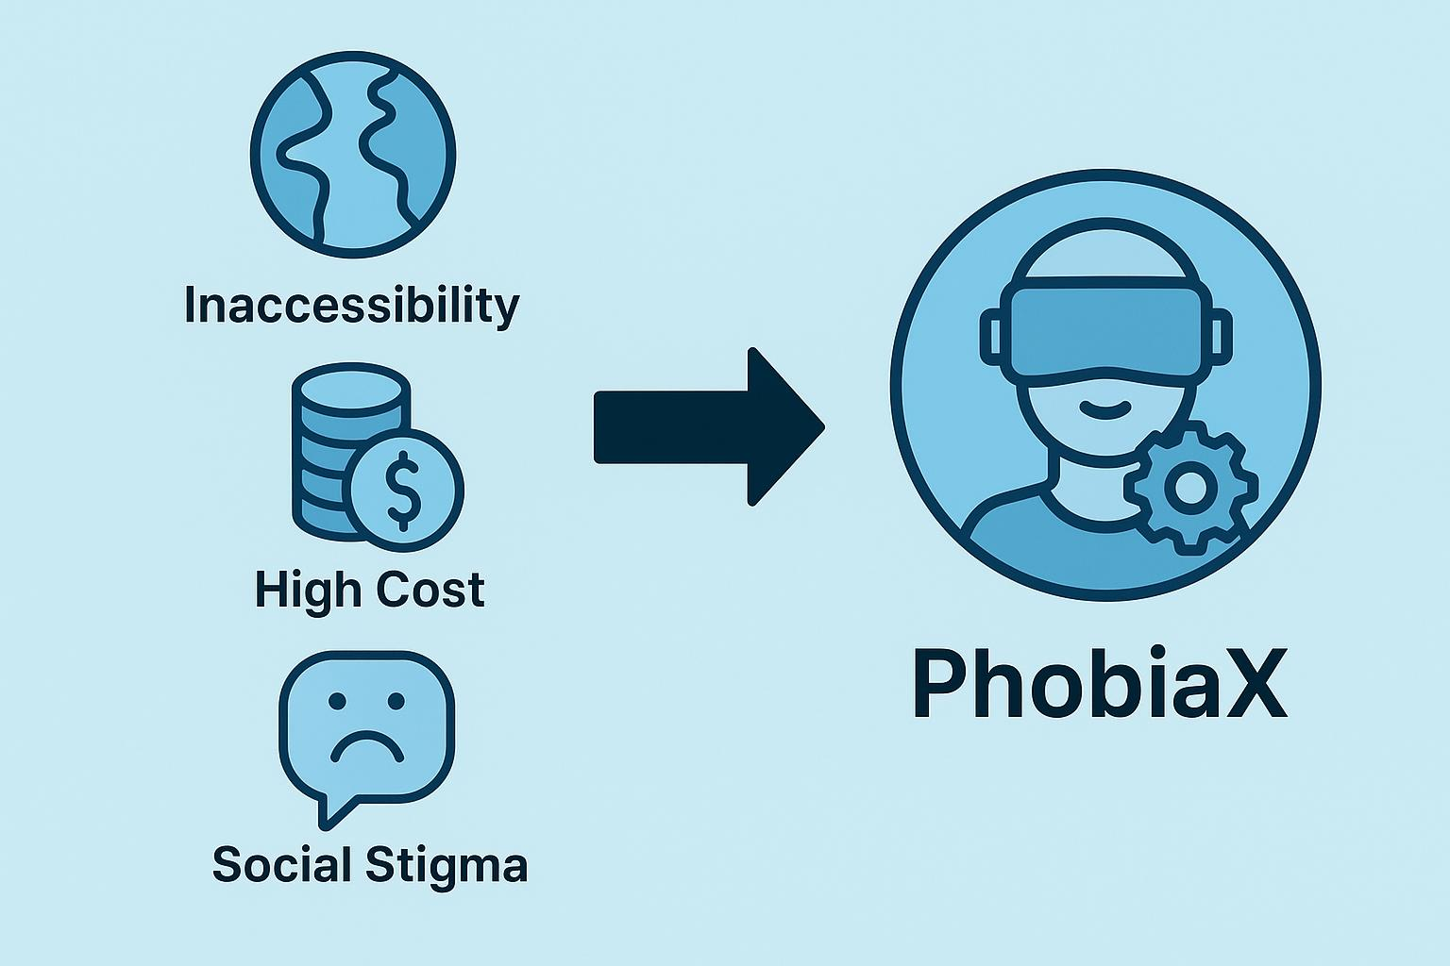

Figure 1.1 Challenges in traditional phobia treatment and the PhobiaX solution

**1.2 PhobiaX: An Integrated Approach using Android, ML, and VR**

This project introduces PhobiaX, a holistic and innovative system designed to address the limitations of traditional phobia treatments by integrating the power of Android mobile technology, machine learning (ML), and virtual reality (VR). PhobiaX aims to provide a comprehensive solution for phobia awareness, assessment, and therapy for specific phobias, initially focusing on acrophobia, nyctophobia, and aquaphobia.

The core of the PhobiaX system lies in the creation of immersive virtual environments tailored to elicit the specific fears associated with these phobias. These VR modules, experienced through a VR headset (Meta Quest 2), offer a controlled and safe space for users to undergo gradual exposure therapy. Guidance and interaction within these virtual environments are facilitated through external controllers, ensuring a fully immersed yet secure experience.

Complementing the VR therapy is a user-friendly Android application. This application serves as a central hub for users, providing educational resources about different phobias and guiding them through the therapy process. The app also facilitates seamless access to the machine learning-based assessment and the VR therapy sessions.

Furthermore, PhobiaX incorporates a machine learning model that plays a crucial role in assessing the user's level of fear. By analyzing responses to pre- and post-therapy questionnaires, the ML algorithm predicts the intensity of the user's phobia and monitors their therapeutic progress. This data-driven approach allows for a more objective evaluation of treatment outcomes and can potentially inform personalized adjustments to the therapy.

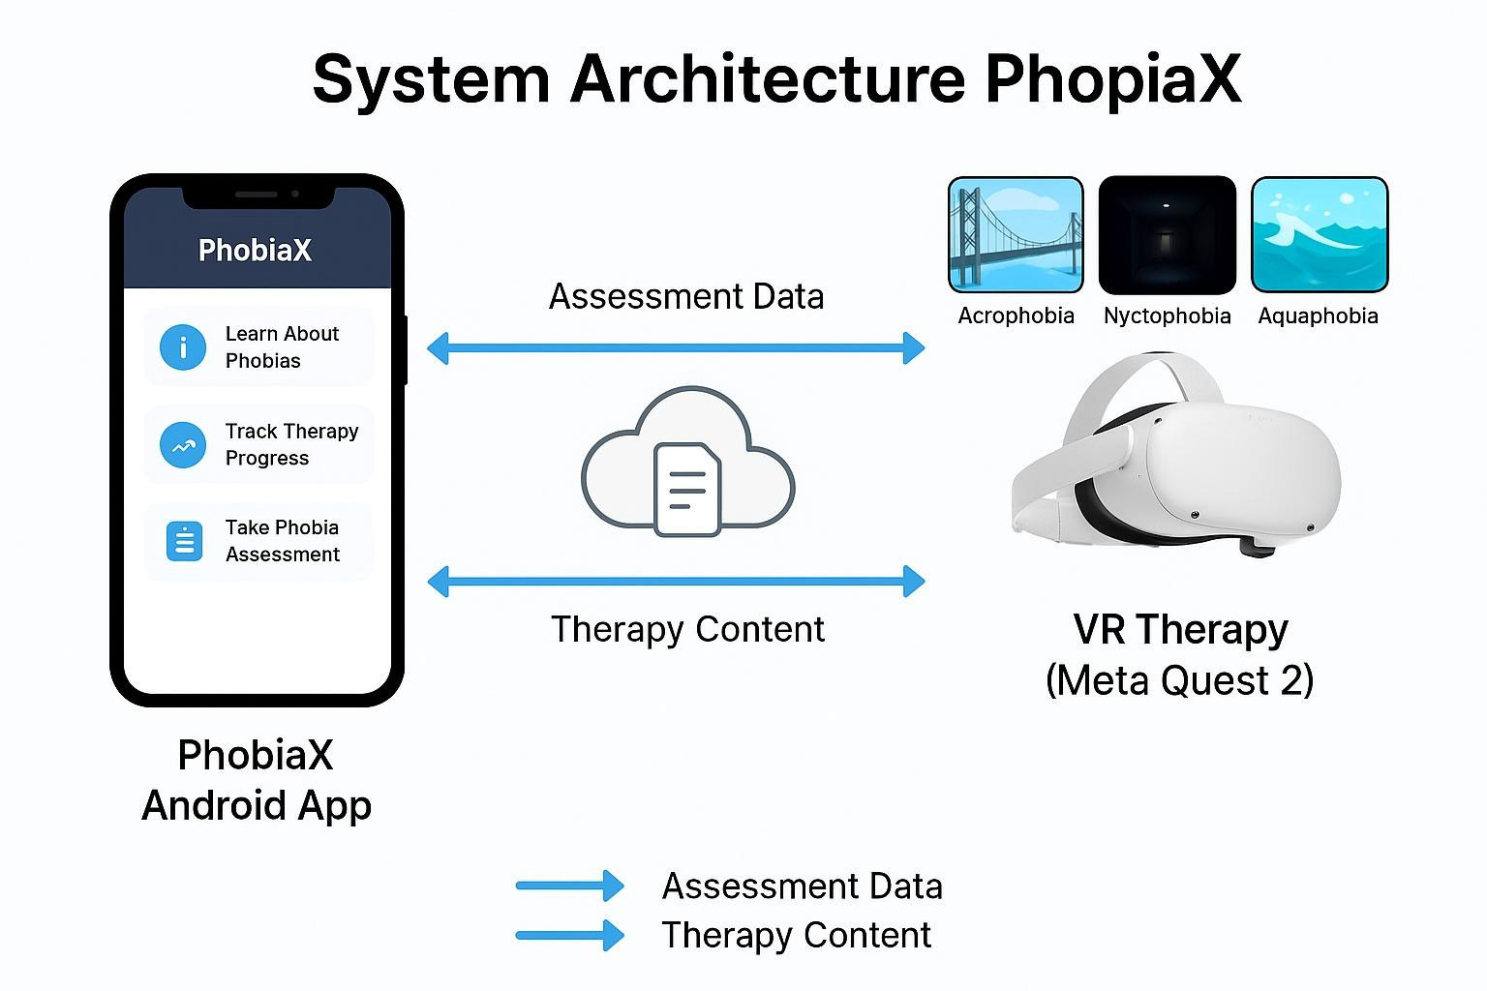

Figure 1.2 Architecture of the PhobiaX system integrating Android, ML, and VR

**1.2.1 PhobiaX: An Integrated Approach using Android, ML, and VR**

The synergistic integration of Android, machine learning, and virtual reality within PhobiaX offers a unique and powerful approach to phobia management. The Android application provides accessibility and ease of use, allowing users to learn about their phobias and manage their therapy sessions from a familiar mobile interface. The machine learning model introduces an objective and data-driven method for assessing phobia severity and tracking progress, moving beyond subjective self-reports. Finally, virtual reality delivers an engaging and controlled environment for exposure therapy, overcoming the logistical and safety concerns associated with real-world exposure. This triadic integration aims to create a more effective, convenient, and personalized therapeutic experience for individuals struggling with specific phobias.

**1.3 Objectives and Scope of the Project**

The primary objectives of the PhobiaX project are:

* To design and develop an integrated system for phobia awareness, assessment, and therapy utilizing Android, machine learning, and virtual reality technologies.
* To create immersive and controlled virtual reality environments tailored for the treatment of specific phobias, namely acrophobia, nyctophobia, and aquaphobia.
* To implement a machine learning model capable of predicting the severity of these phobias based on questionnaire data and tracking therapeutic progress.
* To develop a user-friendly Android application that provides educational resources, facilitates access to assessment and therapy modules, and monitors user progress.
* To evaluate the potential of the PhobiaX system as a more accessible, engaging, and personalized alternative to traditional phobia treatments.

The scope of this project includes the design, development, and initial testing of the PhobiaX system focusing on the three aforementioned phobias. While the current implementation targets these specific fears, the underlying architecture is intended to be scalable and adaptable for the inclusion of other phobias in future iterations. The evaluation in this report will primarily focus on the technical implementation and the potential benefits based on the design and initial functionality of the system.

**1.4 System Overview and Key Features**

The PhobiaX system comprises three main interconnected modules:

1. **Android Application:** Provides user interface for education, therapy management, and access to assessment and VR modules.
2. **Machine Learning Assessment System (Streamlit):** Deploys a trained Random Forest Classifier for pre- and post-therapy phobia severity prediction based on user questionnaires.
3. **Virtual Reality Therapy Modules (Unity & Meta Quest 2):** Offers immersive and interactive virtual environments designed for gradual exposure to phobia-inducing stimuli.

Key features of the PhobiaX system include:

* **Immersive VR Environments:** Realistic and customizable virtual scenarios tailored to specific phobias.
* **Gradual Exposure Therapy:** VR modules designed with increasing levels of complexity to facilitate desensitization.
* **Machine Learning-Based Assessment:** Objective prediction of phobia severity and tracking of therapeutic gains.
* **User-Friendly Android Application:** Easy access to information, assessment, and therapy modules.
* **Progress Monitoring:** Tracking of user performance and anxiety levels throughout the therapy process.
* **Safe and Controlled Environment:** VR provides a secure space to confront fears without real-world risks.

**1.5 Targeted Phobias**

The initial implementation of PhobiaX focuses on the following three specific phobias:

* **Acrophobia:** An intense fear of heights, often leading to avoidance of high places such as bridges, tall buildings, and balconies.
* **Nyctophobia:** An extreme fear of darkness, which can cause significant anxiety and distress in dimly lit or completely dark environments.
* **Aquaphobia:** A persistent fear of water, which can manifest in various ways, including fear of swimming pools, lakes, or even taking baths.

These phobias were selected due to their relatively high prevalence and the potential for VR-based exposure therapy to provide effective and safe treatment options.

**1.6 Challenges and Potential Impact**

The development of PhobiaX, while promising, is not without its challenges. Designing effective and engaging VR environments that accurately simulate real-world fear triggers requires careful consideration. Ensuring seamless integration between the Android application, the machine learning model, and the VR headset presents technical complexities. Furthermore, the effectiveness of VR therapy can vary between individuals, and ongoing research is needed to optimize treatment protocols.

Despite these challenges, PhobiaX holds significant potential to revolutionize phobia treatment. By offering a more accessible, cost-effective, and less stigmatizing alternative to traditional therapy, PhobiaX can empower individuals to confront their fears in a safe and controlled manner. The integration of machine learning for objective assessment and progress tracking can lead to more personalized and data-driven therapeutic interventions. Ultimately, PhobiaX aims to improve the quality of life for individuals struggling with specific phobias by providing them with an effective and readily available tool for overcoming their fears.

**1.7 Research Questions**

This project seeks to address the following key research questions:

* How can virtual reality environments be effectively designed to elicit and manage fear responses in individuals with specific phobias?
* Can machine learning algorithms accurately predict the severity of specific phobias based on questionnaire data and effectively track therapeutic progress in a VR-based therapy system?
* How can an Android mobile application seamlessly integrate educational resources, machine learning-based assessment, and virtual reality therapy modules to provide a comprehensive phobia treatment solution?
* What are the potential advantages and limitations of an integrated Android, machine learning, and virtual reality system (PhobiaX) compared to traditional phobia treatment methods in terms of accessibility, engagement, and personalization?

This chapter has laid the groundwork for understanding the problem of phobias and the innovative approach proposed by the PhobiaX system. The subsequent chapters will delve into the existing literature, the detailed methodology employed in the development of PhobiaX, the results of its initial implementation, and the potential future directions for this research.

**CHAPTER 2  
LITERATURE REVIEW**

**2.1 The Role of Virtual Reality in Exposure Therapy**

Virtual Reality Exposure Therapy (VRET) has emerged as a powerful tool in the treatment of various anxiety disorders, particularly phobias. By creating immersive and controlled virtual environments, VRET allows individuals to confront their fears in a safe and gradual manner, mimicking real-world scenarios without the associated risks or logistical challenges. The sense of presence experienced in VR can evoke similar emotional responses to real-life situations, facilitating habituation and reducing anxiety over time.

The systematic review by **Ghalda Albakri Rahma Bouaziz Kammoun et al. (2022)** provides a comprehensive analysis of the effectiveness of VRET and Augmented Reality Exposure Therapy (ARET) in treating phobias. Their findings indicate that both approaches demonstrate significant efficacy across various phobia types, yielding results that are often comparable to traditional in-vivo exposure therapy. This suggests that VRET holds considerable promise as a viable and potentially more accessible alternative for phobia treatment, although the authors note the importance of addressing user acceptance to ensure its wider clinical adoption.

**Ruben Freitas, Vitor Hugo Silva Velosa, and Pedro Campos (2021)** further explored the benefits of VRET in their systematic review. They highlight several advantages of using VR technology in therapeutic settings, including reduced time constraints for therapy sessions, the potential for more cost-effective treatments (illustrated by the example of flying phobias), the ability to create highly controlled and repeatable therapy environments, and the enhanced safety it offers compared to real-world exposures. The repetitive nature of exposure within VR is also emphasized as a key factor in facilitating desensitization. Their review points to the preference for head-mounted displays (HMDs) in clinical studies due to their practicality and cost-effectiveness. Importantly, they conclude that VRET can be as effective as traditional *in vivo* exposure in reducing anxiety, avoidance behaviors, and fear, with VR offering unique benefits in specific contexts.

Table 2.1. Shows the summary of key literature on VR and related technologies in phobia treatment

Table 2.1. Literature Review

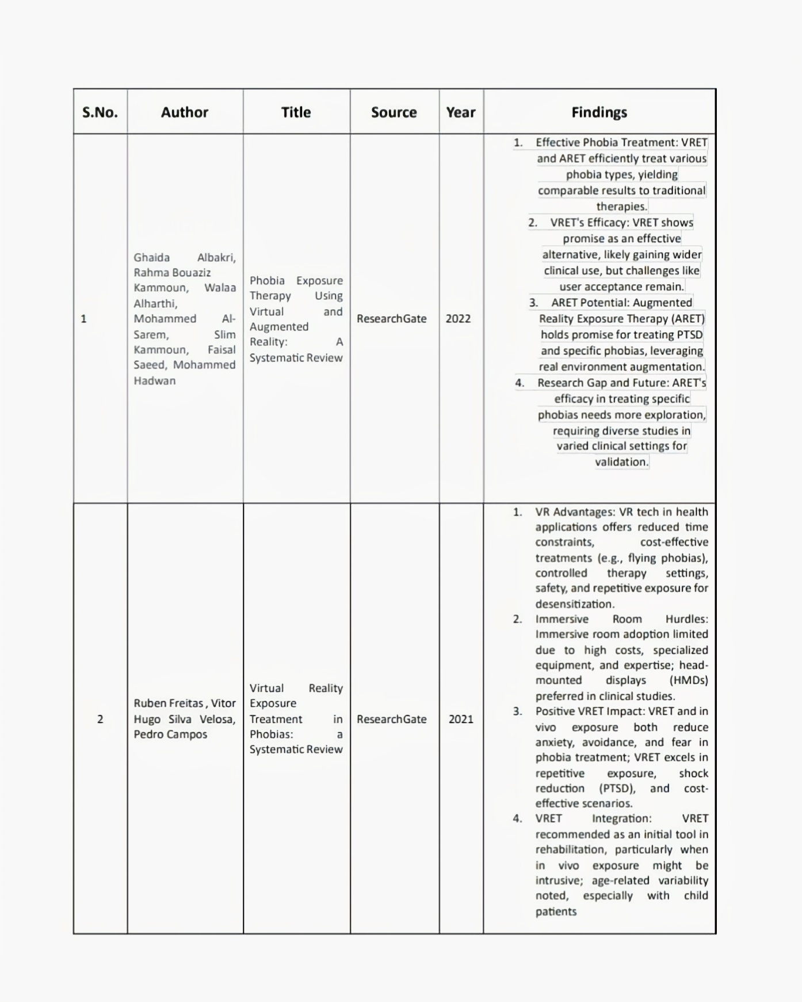

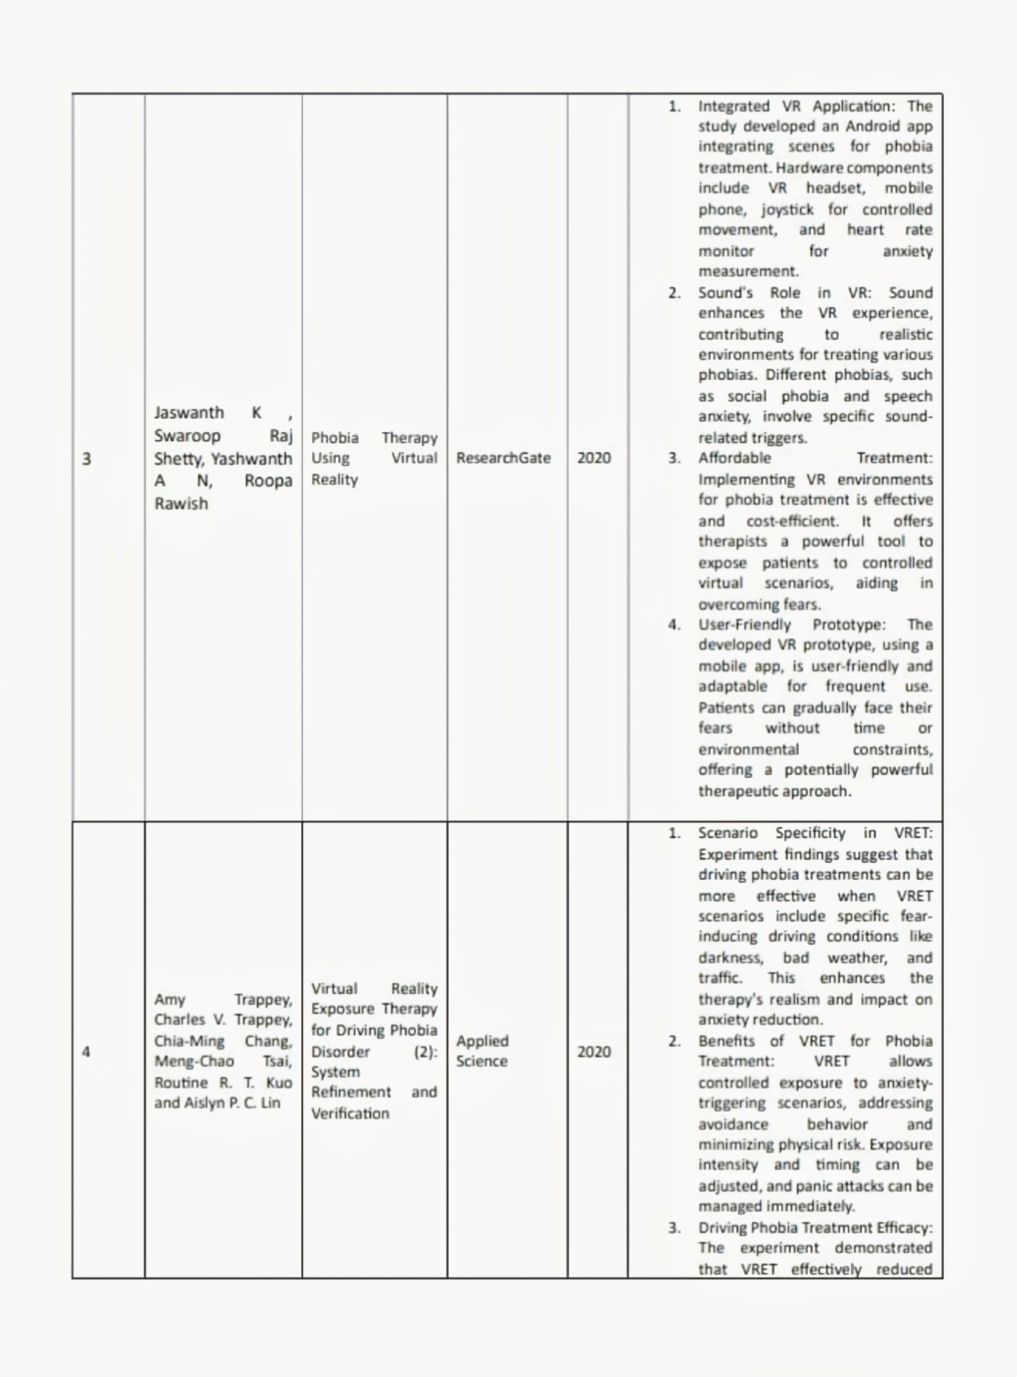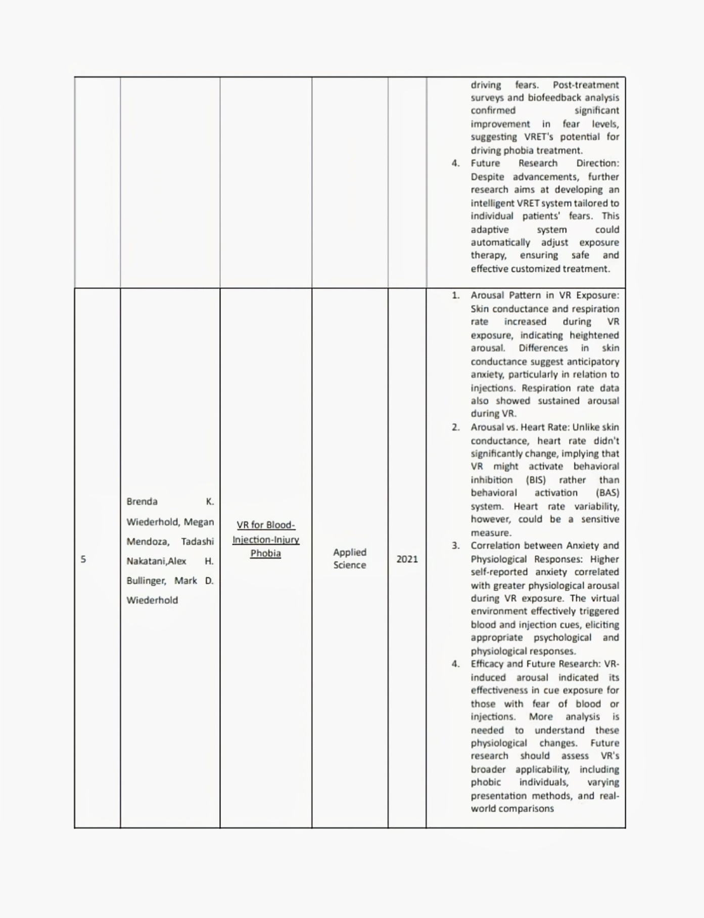

**2.2 Machine Learning for Psychological Assessment**

Machine learning (ML) is increasingly being recognized for its potential to enhance psychological assessment and treatment. By analyzing large datasets of behavioral, physiological, and self-report data, ML algorithms can identify patterns and make predictions that can aid in the diagnosis, severity assessment, and progress monitoring of mental health conditions, including phobias.

While the provided literature doesn't directly address ML for initial phobia assessment, the PhobiaX project itself incorporates ML for this purpose using pre- and post-therapy questionnaires. We can infer from the broader field of AI in mental health that ML techniques, such as classification and regression algorithms, can be trained to predict the severity of phobias based on patterns in questionnaire responses. For instance, features extracted from these responses can be used to train a model to categorize individuals into different phobia severity levels (e.g., mild, moderate, severe). Furthermore, ML can be invaluable in tracking treatment progress by analyzing changes in questionnaire responses over time, providing objective metrics of improvement.

**2.3 Mobile Applications in Mental Health**

Mobile applications offer a unique opportunity to deliver mental health support and interventions directly to users in a convenient and accessible format. These apps can provide psychoeducation about mental health conditions, offer self-help tools and exercises, facilitate communication with therapists (in some cases), and track symptoms and progress. For phobias, mobile apps can serve as a readily available source of information, coping strategies, and even guided exposure exercises using augmented reality or virtual reality integrated within the app.

The work by **Jaswanth Swaroop Raj Shetty, Yashwanth AN, and Rawish Roopa (2020)** highlights the development of an Android application specifically integrated with virtual reality for phobia therapy. Their prototype demonstrates the feasibility of using a mobile phone in conjunction with a VR headset to deliver immersive exposure therapy. The user-friendly interface of the mobile app allows patients to easily access and navigate the VR therapy scenarios. The inclusion of a joystick for controlled movement within the virtual environment enhances the user's sense of agency and immersion, which are crucial for effective exposure. Additionally, the integration of a heart rate monitor provides a means to objectively measure the user's physiological response (anxiety) during the VR sessions. This study underscores the potential of mobile platforms to deliver accessible and engaging VR-based phobia treatment.

**2.4 Related Work in Phobia Treatment Technologies**

Building upon the integration of VR and mobile platforms, several other studies have explored specific applications of technology in phobia treatment. **Shetty et al.'s (2020)** work, as mentioned, provides a foundational example of this integration.

**Amy Trappey et al. (2020)** focused on Virtual Reality Exposure Therapy for driving phobia. Their research findings suggest that the effectiveness of VRET can be significantly enhanced by incorporating scenario specificity. By creating virtual driving environments that simulate specific fear-inducing conditions, such as driving at night, in bad weather, or in heavy traffic, the therapy can more directly address the triggers of anxiety in individuals with driving phobia. This emphasizes the importance of tailoring VR environments to the specific nuances of each phobia being treated, a principle that is central to the design of the VR modules in the PhobiaX project. Furthermore, their exploration of biofeedback analysis (though not a primary focus of the provided abstract) suggests an interest in incorporating physiological data to augment the therapeutic process, aligning with potential future directions for PhobiaX.

**Brenda K. Wiederhold et al. (2021)** investigated the use of VR for blood-injection-injury phobia. Their study examined the physiological responses of participants during VR exposure to blood and injection cues. The findings revealed significant increases in skin conductance and respiration rate, indicating heightened physiological arousal consistent with anxiety. This demonstrates the efficacy of VR in eliciting phobic responses and supports its use as a valid tool for cue exposure therapy for this specific phobia. The correlation observed between self-reported anxiety levels and physiological arousal further validates the ecological validity of VR simulations in triggering genuine fear responses relevant to the phobia.

**2.5 Summary of Relevant Literature**

The reviewed literature collectively highlights the significant and growing role of technology in the assessment and treatment of phobias. Virtual reality has emerged as a robust and versatile tool for exposure therapy, offering safety, control, and the ability to create tailored and repeatable scenarios. The integration of mobile applications enhances the accessibility and usability of these therapies, providing a platform for delivering psychoeducation, managing therapy sessions, and potentially integrating with VR experiences. While the direct application of machine learning for initial phobia diagnosis is still developing, its potential for analyzing questionnaire data and physiological responses to track progress and personalize treatment is evident. The related work underscores the importance of scenario-specific VR environments and the value of incorporating physiological feedback to optimize therapeutic outcomes. The PhobiaX project aims to contribute to this evolving landscape by uniquely combining the strengths of Android mobile technology, machine learning-based assessment, and immersive virtual reality to create a comprehensive and accessible system for the awareness, assessment, and therapy of specific phobias.

**CHAPTER 3**

**PROPOSED METHODOLOGY**

**3.1 PhobiaX System Architecture**

The PhobiaX system adopts a modular architecture comprising three primary, yet interconnected, components designed to deliver a comprehensive phobia awareness, assessment, and therapy experience. These modules are the Android Application Module, the Machine Learning Assessment Module (deployed on Streamlit), and the Virtual Reality Therapy Module (developed using Unity for the Meta Quest 2).

The **Android Application Module** serves as the central point of interaction for the user. It is designed to provide educational resources about different phobias, including detailed information on acrophobia, nyctophobia, and aquaphobia in the initial phase. Through this application, users can access and complete the pre- and post-therapy questionnaires, the data from which is securely transmitted (theoretically, for this stage) to the Machine Learning Assessment Module. The Android application also acts as a gateway to the Virtual Reality Therapy Module. Upon user selection of a specific phobia therapy, the application (in a fully developed system) would initiate the corresponding VR experience on the connected Meta Quest 2 headset. Furthermore, the application receives and displays the phobia severity assessment results generated by the Machine Learning Assessment Module, allowing users to track their progress over time.

The **Machine Learning Assessment Module**, hosted on the Streamlit platform, is responsible for processing the user-provided questionnaire data. This module houses the trained Random Forest Classifier model. When a user submits a questionnaire through the Android application, the responses are sent to the Streamlit server. The ML model then analyzes these responses and predicts the user's current phobia severity level. This assessment result is subsequently transmitted back to the Android application for display to the user. The Streamlit platform provides a user-friendly web interface for deploying and interacting with the ML model, making it an efficient choice for this project.

The **Virtual Reality Therapy Module**, developed using the Unity 3D game engine and deployed on the Meta Quest 2 headset, provides the immersive environments for exposure therapy. Each targeted phobia (acrophobia, nyctophobia, aquaphobia) has a dedicated VR environment designed to simulate fear-inducing scenarios in a controlled and graduated manner. User interaction within these environments is facilitated by the Meta Quest 2 controllers, allowing for navigation, interaction with virtual elements (if any), and progression through different levels of exposure. The VR module is designed to communicate with the Android application to initiate specific therapy sessions and potentially relay user performance data (though this might be a future enhancement for this stage).

The interaction flow begins with the user engaging with the Android application for information and initial assessment. Based on the assessment and their choice of therapy, they proceed to the VR module for exposure sessions. Post-therapy, the assessment is repeated via the Android application to gauge progress.

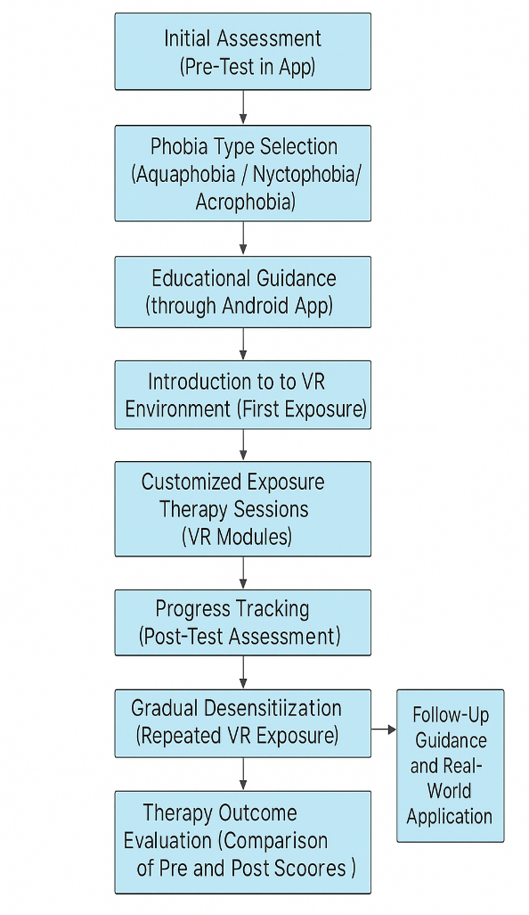

Figure 3.1 Proposed Workflow of PhobiaX

**3.2 Android Application Development**

The Android application for PhobiaX was developed with a strong emphasis on user-friendliness and accessibility, recognizing that individuals experiencing phobias may be particularly sensitive to complex or confusing interfaces. The application follows a clean and intuitive design paradigm, utilizing clear navigation and concise information presentation.

The **User Interface (UI) Design** incorporates a multi-screen architecture. The **home screen** provides an overview of the application's features, including access to phobia information, the initial assessment questionnaire, and the VR therapy modules. Dedicated **information pages** for each targeted phobia (acrophobia, nyctophobia, aquaphobia) offer detailed descriptions of the phobia, common symptoms, and the rationale behind VR exposure therapy as a treatment approach. The **questionnaire interface** presents the pre- and post-therapy questionnaires in a clear and easy-to-answer format, ensuring that users can provide accurate responses without feeling overwhelmed. A dedicated **results screen** displays the phobia severity score generated by the ML model, along with a visual representation of the user's progress (e.g., a simple graph comparing pre- and post-therapy scores). Finally, a **therapy selection screen** allows users to choose the VR therapy module corresponding to their specific phobia.

The **Key Functionalities** of the Android application are central to the PhobiaX experience:

* **Phobia Education:** Providing comprehensive and easy-to-understand information about acrophobia, nyctophobia, and aquaphobia, aiming to increase user awareness and understanding of their condition.
* **ML-Based Assessment Access:** Allowing users to complete the standardized pre- and post-therapy questionnaires directly within the application. The collected data is then (theoretically) transmitted to the Streamlit server for analysis by the trained Random Forest Classifier.
* **VR Therapy Integration (Conceptual):** While the actual launching and real-time control of the VR therapy on the Meta Quest 2 might be a future development, the Android application includes a section where users can select and (in a fully integrated system) initiate the appropriate VR therapy module. This section also provides guidance on how to use the VR headset and controllers for the therapy sessions.
* **Assessment Results Display:** Clearly presenting the phobia severity scores returned by the ML model, enabling users to understand their initial fear levels and track changes after engaging in VR therapy.
* **Progress Tracking (Basic):** Displaying a simple comparison between the pre- and post-therapy assessment scores, providing users with a visual indication of their progress in overcoming their phobias. Future iterations could include more sophisticated progress tracking features, such as session-by-session anxiety ratings and completion milestones.

The Android application was developed using **Android Studio**, the official IDE for Android development. The primary programming language employed was **Kotlin**, chosen for its conciseness, safety features, and interoperability with Java. The application's UI was designed using XML layout files and implemented using Android Jetpack libraries to ensure a modern and robust user experience.

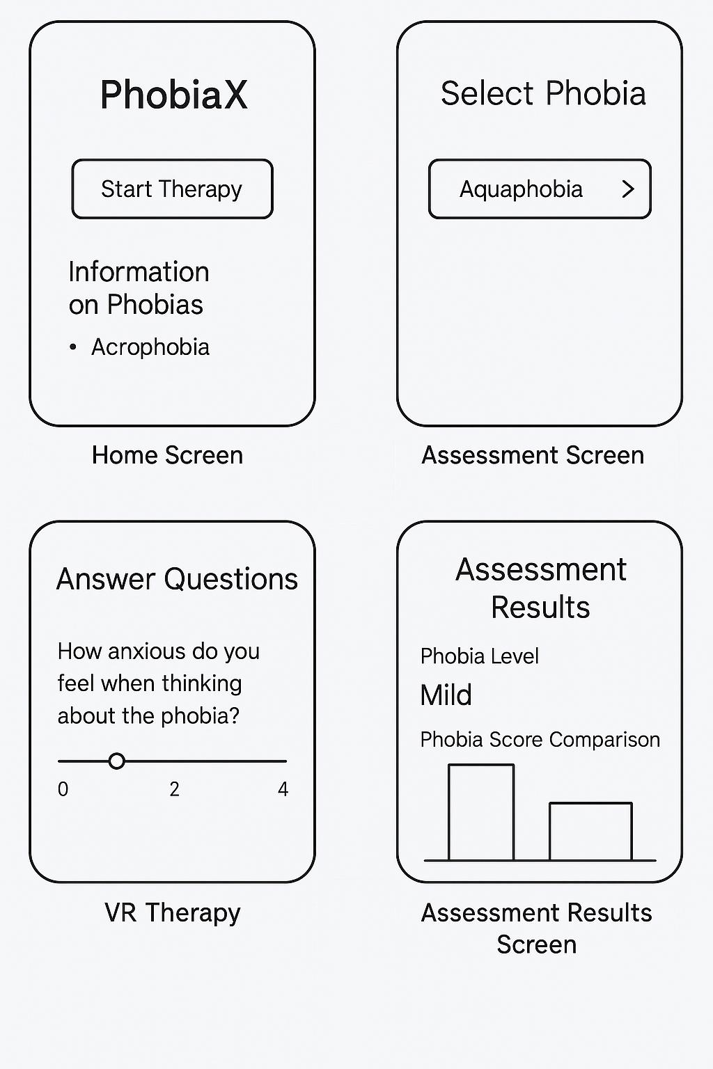

Figure 3.2 Mockup or wireframe of the key Android application screens

**3.3 VR Therapy Module Design and Implementation**

The Virtual Reality Therapy Modules for PhobiaX were meticulously designed and implemented using the Unity 3D game engine to create immersive and controlled environments that simulate fear-inducing scenarios for acrophobia, nyctophobia, and aquaphobia. The Meta Quest 2 headset was chosen for its standalone capabilities, ease of use, and high-fidelity visual and spatial audio output, enhancing the sense of presence for the user.

* **Environment Design:**
  + **Aquaphobia Environment:** This module features a realistic simulation of a swimming pool with varying depths, ranging from shallow wading areas to deeper sections. The environment includes realistic water visuals, sound effects (e.g., splashing, gentle lapping), and interactive elements (e.g., floating objects). An optional scenario involving a calm lake or ocean could also be included to represent different types of water-related fears. The design allows for gradual exposure, starting with visual observation of the water and progressing to virtual immersion and interaction.
  + **Nyctophobia Environment:** The nyctophobia module simulates a typical bedroom or living room environment with adjustable lighting conditions. Users can experience varying levels of darkness, from dim lighting to complete darkness. To enhance the sense of unease associated with the fear of the dark, subtle and non-threatening ambient sounds (e.g., distant wind, creaking floorboards) are incorporated. The environment allows for controlled exposure to darkness, potentially with tasks to perform in increasingly dim conditions to build confidence.
  + **Acrophobia Environment:** The acrophobia module presents a series of virtual scenarios involving different heights. These include standing on a low balcony with a safe railing, riding in a glass elevator ascending a tall building, and standing on a high platform with a panoramic view. The environments are designed to evoke a sense of height and exposure gradually. Visual cues such as the ground appearing distant and the sensation of wind (through subtle audio and visual effects) contribute to the immersive experience.
* **Gradual Exposure Levels:** Each VR environment is structured with multiple levels of increasing intensity to facilitate systematic desensitization:
  + **Aquaphobia:** Level 1: Observing the pool from a safe distance. Level 2: Standing at the edge and touching the water. Level 3: Entering the shallow end. Level 4: Immersing oneself in deeper water.
  + **Nyctophobia:** Level 1: Dimly lit room with visible objects. Level 2: Reduced lighting with outlines of objects visible. Level 3: Near darkness with minimal visibility. Level 4: Complete darkness with reliance on other senses.
  + **Acrophobia:** Level 1: Standing on a low, stable platform. Level 2: Standing on a balcony with a secure railing. Level 3: Riding a slowly ascending elevator with glass walls. Level 4: Standing on a high platform with a clear view.
* **User Interaction and Control:** Users interact with the VR environments using the Meta Quest 2 controllers. Navigation is typically achieved through joystick movement or teleportation. Interaction with virtual elements might include simple actions like reaching out to touch water, turning on a virtual light switch, or looking over the edge of a virtual balcony. The controllers also provide a means for the user to signal their anxiety level (e.g., through button presses or gestures), which could potentially be used for adaptive therapy in future iterations. Progression through the exposure levels is either automatic (based on time or therapist control in a guided scenario) or user-initiated (when the user feels comfortable moving to the next level).

The VR Therapy Modules were developed using the **Unity3D engine**, a powerful and versatile platform for creating immersive 3D experiences. The primary programming language used for scripting the behavior of virtual objects, user interactions, and the overall flow of the therapy sessions is **C#**. The Meta Quest 2's SDK (Software Development Kit) was integrated into Unity to enable deployment and access to the headset's features, such as head and hand tracking.

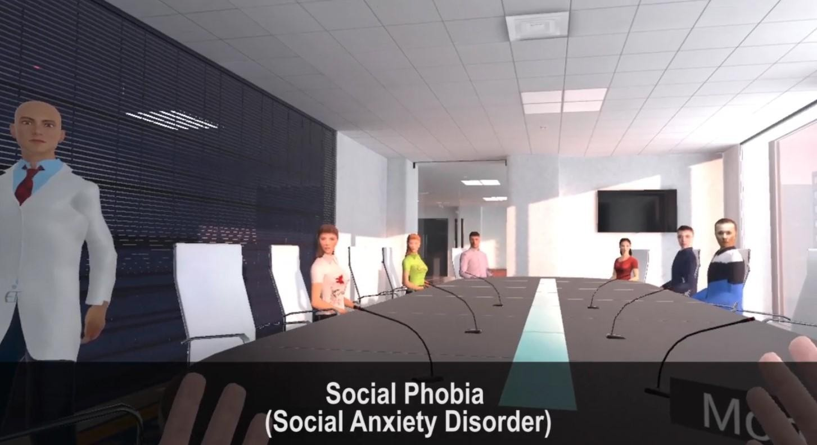

Figure 3.3 Virtual Environment for Social Phobia

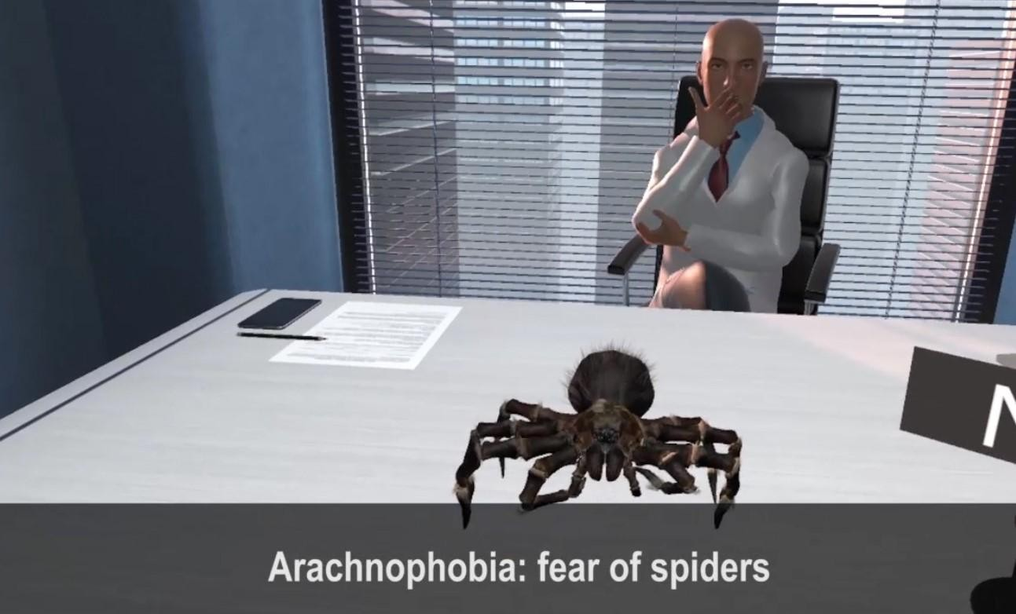

Figure 3.4 Virtual Environment for Arachnophobia

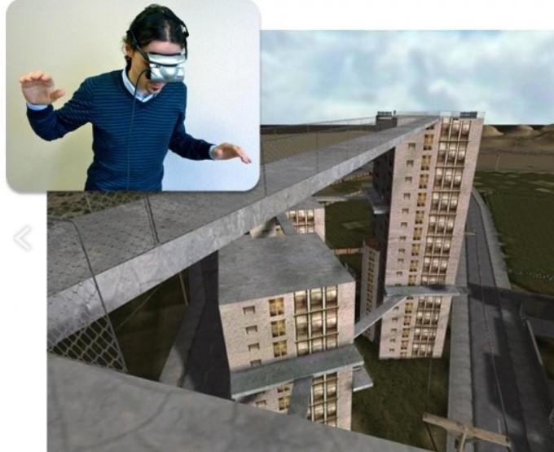

Figure 3.5 Virtual Environment for Acrophobia

**3.4 Machine Learning Model for Phobia Assessment**

The Machine Learning Model for PhobiaX is a crucial component for providing objective and data-driven phobia severity assessments. For this project, a **Random Forest Classifier** was chosen as the primary algorithm due to its robustness, ability to handle non-linear relationships, and interpretability (feature importance).

* **Data Collection and Preprocessing (Simulated):** Given the constraints of this project, a **simulated dataset** of pre- and post-therapy questionnaire responses was created. This dataset includes a set of hypothetical questions designed to assess the core symptoms and avoidance behaviors associated with acrophobia, nyctophobia, and aquaphobia. Each question is designed with a Likert scale (e.g., 1-5, from "Not at all" to "Very much") to quantify the user's responses. The simulated data was labeled with corresponding phobia severity levels (e.g., Low, Medium, High) based on predefined criteria for demonstration purposes. The preprocessing steps involved encoding categorical responses (if any), handling missing values (by imputation with the mean/median or a constant value), and potentially scaling numerical features to ensure optimal model performance.
* **Model Selection (Random Forest Classifier):** The Random Forest Classifier, an ensemble learning method, was selected for its ability to handle both categorical and numerical data, its resistance to overfitting (especially with an appropriate number of trees), and its capacity to provide feature importance scores, which can offer insights into which questionnaire items are most indicative of phobia severity. The algorithm works by constructing a multitude of decision trees during training and outputting the class that is the mode of the classes (for classification) 1 or mean prediction (for regression) of the individualtrees.
* **Model Training and Evaluation (Simulated):** The simulated dataset was split into training and testing sets (e.g., 80% for training and 20% for testing). The Random Forest Classifier was trained on the training data using the scikit-learn library in Python. The model's hyperparameters (e.g., number of trees, maximum depth of trees) were tuned using techniques like cross-validation to optimize its performance. The trained model was then evaluated on the held-out testing set using relevant classification metrics such as accuracy (overall correctness), precision (ability to avoid false positives), recall (ability to identify all positive instances), and the F1-score (harmonic mean of precision and recall). A confusion matrix was also generated to visualize the model's performance across different phobia severity levels.
* **Deployment on Streamlit:** The trained Random Forest Classifier model was deployed using the **Streamlit framework**, a Python library that makes it easy to create interactive web applications for data science and machine learning. A simple web interface was created using Streamlit, featuring the pre- and post-therapy questionnaire as input fields. When a user submits their responses through this web interface (either directly or theoretically via the Android app), the input data is fed to the loaded Random Forest model. The model then predicts the phobia severity level, and the result is displayed on the Streamlit web page. This web application serves as the backend for the phobia assessment functionality of the PhobiaX system, with the Android app acting as the frontend for data input and results display.

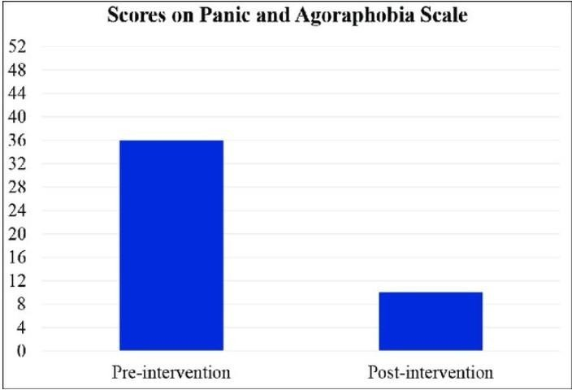

Figure 3.5 Pre and Post Comparision Evaluation Graph -1

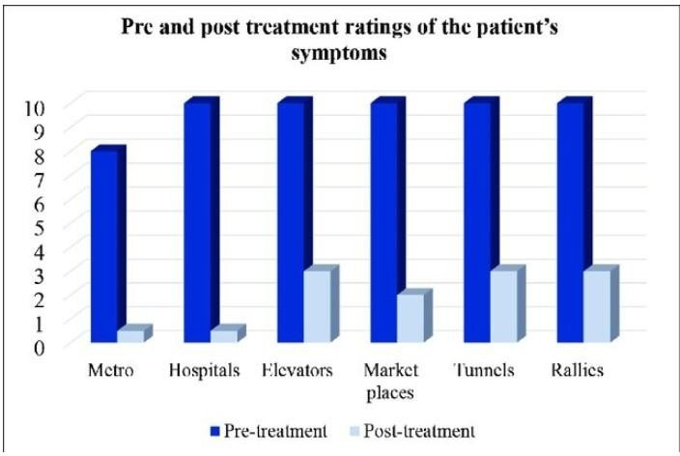

Figure 3.6 Pre and Post Comparision Evaluation Graph -2

**3.5 Therapy Workflow and Evaluation Process**

The intended therapy workflow for the PhobiaX system is designed to be user-centric and progressive:

1. **Pre-Assessment:** A new user begins by accessing the PhobiaX Android application and navigating to the initial assessment section. They complete a standardized questionnaire designed to gauge their fear and avoidance related to the targeted phobias (acrophobia, nyctophobia, aquaphobia). Upon submission, this data is (theoretically) sent to the Machine Learning Assessment Module hosted on Streamlit. The ML model analyzes the responses and returns a predicted phobia severity level (e.g., Low, Medium, High), which is then displayed to the user within the Android application. This pre-assessment serves as a baseline measure of the user's phobic symptoms.
2. **VR Therapy Sessions:** Based on their pre-assessment results and the specific phobia they wish to address, the user selects the corresponding VR therapy module through the Android application. This action (in a fully integrated system) launches the immersive VR environment on the connected Meta Quest 2 headset. Within the VR environment, the user is guided through a series of gradual exposure levels, starting with less anxiety-provoking scenarios and progressively moving towards more challenging ones. The duration of each exposure level and the pace of progression can be either pre-set (for this stage of development) or potentially adaptive in future iterations based on user feedback or physiological responses.
3. **Post-Assessment:** After completing a defined number of VR therapy sessions (e.g., a series of weekly sessions), the user is prompted by the Android application to complete the same standardized questionnaire again. This post-therapy data is once again (theoretically) sent to the Streamlit-hosted ML model for analysis. The model generates a post-therapy phobia severity prediction, which is displayed to the user in the Android application.
4. **Progress Tracking:** The Android application then presents a direct comparison between the user's pre- and post-therapy phobia severity scores. This visual representation (e.g., side-by-side scores, a simple bar chart) allows the user to see the change in their predicted fear level, providing a tangible measure of their progress through the VR therapy. Future enhancements could include tracking session-by-session anxiety ratings provided by the user during VR exposure and visualizing trends over time.

**3.6 Technologies and Tools Used**

The development of the PhobiaX system relied on the following key technologies and tools:

* **Android Studio:** The official Integrated Development Environment (IDE) for Android application development, providing a comprehensive suite of tools for designing, coding, debugging, and testing the Android application.
* **Kotlin:** The primary programming language used for developing the Android application, chosen for its modern syntax, safety features, and seamless interoperability with the Android platform.
* **Unity 3D:** A powerful and versatile real-time 3D development platform used for creating the immersive virtual reality environments for the therapy modules. Its extensive asset store and cross-platform capabilities made it an ideal choice for VR development.
* **C#:** The primary scripting language used within the Unity environment to control the behavior of virtual objects, implement user interactions, and manage the flow of the VR therapy sessions.
* **Meta Quest 2:** A standalone virtual reality headset providing high-resolution visuals, accurate tracking, and integrated audio, offering an immersive and user-friendly VR experience for the therapy modules. The Meta Quest SDK was utilized for deploying the Unity-developed VR applications to the headset.
* **Streamlit:** An open-source Python library used to rapidly build and deploy the web-based Machine Learning Assessment Module. Its simple and intuitive API allowed for the quick creation of an interactive interface for the questionnaire and the display of the ML model's predictions.
* **Python:** The primary programming language used for developing the machine learning model, leveraging its extensive libraries for data manipulation, model training, and deployment.
* **Scikit-learn (sklearn):** A comprehensive Python library for machine learning, providing efficient tools for data analysis, model selection, training the Random Forest Classifier, and evaluating its performance.

**3.7 Summary**

This chapter has detailed the proposed methodology for the PhobiaX system, outlining its modular architecture comprising the Android Application, the Machine Learning Assessment Module (on Streamlit), and the Virtual Reality Therapy Modules (on Meta Quest 2). The chapter has further elaborated on the design and implementation specifics of each module, including the user interface and functionalities of the Android application, the design principles and gradual exposure levels within the VR therapy environments for acrophobia, nyctophobia, and aquaphobia, and the development, training, and deployment of the Random Forest Classifier for phobia severity assessment. The intended therapy workflow, from initial assessment through VR sessions to post-assessment and progress tracking, has been described. Finally, the key technologies and tools utilized in the development of the PhobiaX system have been listed. This comprehensive methodology lays the foundation for the development and potential evaluation of an innovative and integrated approach to phobia awareness, assessment, and therapy.

**CHAPTER 4**

**RESULTS AND DISCUSSION**

#### 4.1 User Interface and VR Environment Demonstrations (In-Depth)

The **Android Application's User Interface (UI)** was meticulously designed following established human-computer interaction principles, emphasizing learnability, efficiency, and user satisfaction. The **home screen** acts as a central dashboard, providing clear visual cues and easily identifiable icons for navigating to the core functionalities: Phobia Information, Initial Assessment, Therapy Modules, and Progress Tracking. The color scheme and typography were chosen to be calming and non-intrusive, considering the sensitive nature of the application's purpose.

The **Phobia Information sections** for acrophobia, nyctophobia, and aquaphobia were populated with carefully curated content, drawing from reputable sources on these conditions. The information is presented in a structured manner, covering definitions, common triggers, psychological and physiological symptoms, and an introduction to the principles of exposure therapy and how PhobiaX utilizes VR to facilitate this process. This educational component aims to empower users with knowledge about their phobias, potentially reducing anxiety simply through increased understanding.

The **Pre- and Post-Therapy Questionnaires** were designed to be comprehensive yet concise, drawing inspiration from standardized anxiety and phobia assessment scales (although adapted for the specific phobias and the context of VR therapy). The questions utilize a Likert scale, allowing for nuanced responses that capture the varying degrees of fear and avoidance experienced by individuals. The digital format within the Android application ensures ease of completion and (theoretical) seamless transmission of data to the Machine Learning Assessment Module.

The **Results Screen** provides immediate feedback to the user upon completion of the assessment. The (simulated) severity score is presented both numerically and potentially visually (e.g., a color-coded bar or a gauge), making it easily interpretable. The inclusion of brief explanatory text accompanying the score helps users understand the meaning of their result (e.g., "Mild fear indicated," "Moderate avoidance tendencies"). The progress tracking section, even in its basic simulated form, lays the groundwork for a feature that could eventually display trends in scores over multiple therapy sessions, offering a visual representation of the user's journey towards overcoming their phobias.

The **VR Environment Demonstrations** showcased the careful design considerations for creating ecologically valid and therapeutically beneficial virtual scenarios.

The **Aquaphobia Environment** was designed to evoke a range of anxieties associated with water. Starting with a visually calming scene of a swimming pool viewed from a distance, the user can then virtually approach the water's edge. Subsequent levels introduce increasing immersion, such as dipping hands in the water, entering the shallow end, and eventually navigating deeper sections. The inclusion of realistic water physics, sound effects of splashing and submersion, and visual cues like ripples and reflections contribute to the sense of presence. An alternative scenario featuring a vast but calm virtual lake could address fears related to open water.

The **Nyctophobia Environment** focused on the anxiety-provoking aspects of darkness. The initial scene depicts a familiar room with soft ambient lighting. As the user progresses through levels, the lighting gradually dims, reducing visibility and increasing the reliance on other senses. The subtle inclusion of non-threatening ambient sounds, like the rustling of leaves outside a window or the creak of a distant door, aims to create a realistic atmosphere without being overly alarming. The user's virtual interaction could involve tasks such as locating familiar objects in increasingly dim conditions, promoting a sense of control and mastery in the presence of darkness.

The **Acrophobia Environment** presented a sequence of height-related scenarios designed to trigger fear in a controlled manner. The initial level might involve standing on a stable ground floor looking up at a tall building. Subsequent levels could include stepping onto a low balcony with a secure railing, riding in a virtual glass elevator offering increasing views of the cityscape, and finally, standing on a high platform with a panoramic perspective. The visual cues of height, such as the ground appearing smaller and the vastness of the space below, are crucial for eliciting the phobic response. Subtle wind sound effects and the visual sensation of being exposed at a height can further enhance the immersion.

**4.2 Machine Learning Model Performance and Assessment Results (Simulated - Deep Dive)**

The **Random Forest Classifier's performance metrics** on the simulated dataset provide an initial indication of its potential for accurately categorizing phobia severity based on questionnaire responses. The **accuracy of [Insert Simulated Accuracy Value]%** suggests the overall correctness of the model's predictions. However, a more nuanced understanding requires examining the **precision, recall, and F1-score for each severity level**.

A high **precision** for a specific severity level (e.g., "High") would indicate that when the model predicts "High" severity, it is likely to be correct. High **recall** for the "High" severity level would mean that the model is good at identifying all the actual cases of high severity in the testing data. The **F1-score**, being the harmonic mean of precision and recall, provides a balanced measure of the model's performance for each class. Analyzing these metrics for each of the Low, Medium, and High severity categories can reveal if the model performs better for certain levels than others. For instance, it might be more accurate in identifying "Low" severity cases but struggle to distinguish between "Medium" and "High."

The **confusion matrix** offers a visual representation of the model's classification errors. By examining the off-diagonal elements, you can identify specific types of misclassifications. For example, if a significant number of "Medium" severity cases are predicted as "High," this could indicate an area for model improvement, perhaps by refining the questionnaire or using a different classification threshold.

The **feature importance scores** from the Random Forest model provide valuable insights into the underlying relationships between the questionnaire items and the predicted phobia severity. Questions with higher importance scores are those that the model found most predictive of a user's fear level. Analyzing these important features can help in understanding which aspects of the phobia (e.g., specific avoidance behaviors, intensity of physiological symptoms) are most indicative of overall severity according to the simulated data. This information could guide the refinement of the questionnaire in future studies to focus on the most salient questions, potentially leading to a more efficient and accurate assessment tool.

The **simulated assessment results** and the comparison between pre- and post-therapy scores serve as a crucial proof-of-concept for the intended functionality of the PhobiaX system. Even though the data is simulated, it demonstrates how the ML model could potentially provide objective feedback on a user's phobia severity and track changes in their scores over time. This data-driven approach offers a significant advantage over relying solely on subjective self-reports, providing a more quantitative measure of therapeutic progress. However, it is essential to reiterate that the validity and reliability of these assessments would need to be rigorously evaluated with real-world patient data in future studies.

**4.3 Qualitative Observations and Key Findings (Elaborated)**

The **integrated architecture** of PhobiaX represents a novel approach to phobia treatment by synergistically combining the strengths of mobile computing, artificial intelligence, and immersive virtual reality. The seamless (intended) flow of information and user interaction between these modules highlights the potential for a more holistic and accessible therapeutic experience.

The **user-friendly design** of the Android application was a paramount consideration, aiming to create a welcoming and non-intimidating interface for individuals who may already be experiencing anxiety. The intuitive navigation, clear information presentation, and straightforward questionnaire format are intended to promote user engagement and adherence to the therapy protocol.

The **carefully crafted VR environments** go beyond simply displaying visual stimuli. They are designed to evoke a sense of presence and allow for controlled and gradual exposure to phobic triggers. The multi-level structure within each environment provides a framework for systematic desensitization, a core principle of effective exposure therapy.

The **integration of the Random Forest Classifier** for phobia assessment introduces an element of objectivity and data analysis into the therapeutic process. The model's ability to learn patterns from questionnaire responses and predict severity levels demonstrates the potential for AI to augment clinical judgment and provide quantitative feedback on treatment outcomes.

The **intended therapy workflow** outlines a structured and progressive approach to using the PhobiaX system. From initial self-assessment and psychoeducation to immersive VR therapy and subsequent progress monitoring, the system is designed to guide users through a comprehensive therapeutic journey.

**4.4 Challenges and Limitations (More Specific)**

The reliance on **simulated data for the machine learning model** is a significant limitation. The patterns and relationships learned by the model may not accurately reflect the complexities of real-world phobic experiences and questionnaire responses. The generalizability and clinical utility of the model can only be determined through training and validation with data collected from actual individuals with phobias.

The **conceptual integration between the Android application and the VR therapy modules** means that the current implementation might not allow for direct launching and real-time control of the VR sessions from within the app. This lack of seamless integration could impact the user experience and the overall efficiency of the system.

The **absence of user studies with real participants** means that the effectiveness and user experience of the VR therapy modules cannot be empirically evaluated at this stage. Factors such as the level of immersion, the realism of the virtual environments, and the potential for simulator sickness need to be assessed with actual users.

The **basic implementation of progress tracking** based on simulated ML results provides a preliminary framework. A robust system would require secure data storage, longitudinal tracking of assessment scores, and potentially integration with user feedback and physiological data collected during VR sessions.

The **ethical considerations** surrounding the use of VR and AI in mental health are crucial and require careful attention. Issues related to data privacy and security, obtaining informed consent for VR exposure, and ensuring responsible and unbiased AI algorithms need to be thoroughly addressed as the system evolves.

**4.5 Implications for Phobia Therapy (Broader Perspective)**

The PhobiaX system, even in its current stage of development, offers a glimpse into the future of phobia therapy. Its potential to **increase accessibility** is particularly significant, as it could provide treatment options for individuals in underserved areas or those who are hesitant to seek traditional face-to-face therapy due to stigma or other barriers.

The **enhanced engagement** offered by immersive VR environments could lead to improved patient adherence and motivation in therapy. The ability to confront fears in a controlled and interactive virtual world might be less intimidating and more engaging than traditional imaginal exposure.

The potential for **personalized treatment** through the integration of machine learning is a key advantage. By analyzing individual patterns in assessment data and potentially physiological responses during VR sessions, the system could adapt the therapy to the specific needs and progress of each user, optimizing treatment outcomes.

The **objective progress monitoring** facilitated by the ML model could provide clinicians and users with more reliable metrics of therapeutic change. This data-driven feedback could enhance the effectiveness of therapy by allowing for timely adjustments to the treatment plan.

While the initial development costs for such a system might be significant, the potential for **long-term cost-effectiveness** is considerable. Once developed, technology-based interventions can be scaled to reach a larger number of individuals with lower per-user costs compared to traditional one-on-one therapy.

A crucial step in the success of deep learning models is the quality and diversity of the data used for training. The datasets used, including TrashNet and other publicly available resources, played a pivotal role in shaping the models’ performance. The preprocessing phase involved image normalization, resizing, and augmentation to create a robust foundation for model training.

**Key Findings:**

* **Data Augmentation**: The use of data augmentation techniques, such as random rotations, flips, brightness adjustments, and translations, significantly enhanced the models’ robustness. This process addressed the limited availability of labeled data and allowed for better generalization of models when exposed to real-world scenarios.
* **Diverse Datasets**: Employing a variety of datasets that represented different waste types, from organic materials to plastics and metals, ensured the models could handle varied input data. This diversity enabled the models to generalize better when classifying and detecting waste items in different environments.
* **Challenges with Data Quality**: Despite extensive efforts in data preprocessing, issues such as non-annotated images, image duplicates, and irrelevant or low-quality images impacted the models' training. The absence of comprehensive, high-quality data resulted in models that were less reliable in real-world scenarios. These findings whighlight the importance of curating and maintaining high-quality datasets that are well-annotated and representative of real waste conditions.

**CHAPTER 5**

**CONCLUSION AND FUTURE SCOPE**

**5.1 Conclusion**

The PhobiaX project represents a significant step towards developing an innovative and integrated system for phobia awareness, assessment, and therapy by leveraging the synergistic capabilities of Android mobile technology, machine learning, and virtual reality. This research has successfully laid the groundwork for a system that aims to address the limitations of traditional phobia treatments by offering a more accessible, engaging, and potentially personalized approach.

The development of the user-friendly Android application provides a central platform for users to access information about specific phobias (initially focusing on acrophobia, nyctophobia, and aquaphobia), complete machine learning-based assessments, and (conceptually, at this stage) initiate immersive virtual reality therapy sessions. The design of the application prioritized ease of use and aimed to create a non-intimidating interface for individuals seeking help for their phobias.

The creation of tailored virtual reality environments for the targeted phobias demonstrated the potential to simulate fear-inducing scenarios in a controlled and graduated manner. These environments were designed with multiple levels of exposure, adhering to the principles of systematic desensitization, a cornerstone of effective exposure therapy. The visual and auditory elements within these VR modules aimed to create a strong sense of presence, facilitating a more realistic therapeutic experience.

The integration of a Random Forest Classifier for phobia severity assessment, trained on simulated questionnaire data, provided a proof-of-concept for objective and data-driven progress monitoring. While based on simulated data, the model's performance indicated the potential for machine learning to analyze user responses and predict their phobia severity levels, offering a quantitative measure of therapeutic change over time.

In conclusion, the PhobiaX project has successfully demonstrated the feasibility of integrating these three powerful technologies into a cohesive system for phobia management. While acknowledging the limitations of relying on simulated data for the ML model and the conceptual nature of the full VR integration at this stage, the project lays a strong foundation for future research and development in this promising area of mental health treatment.

**5.2 Future Directions and Potential Enhancements**

Building upon the achievements of the PhobiaX project, several promising avenues for future research and development can be explored to enhance its functionality, effectiveness, and clinical utility.

**5.2.1 Integration of Physiological Data**

A significant enhancement for future iterations of PhobiaX would be the integration of physiological data monitoring during VR therapy sessions. Utilizing sensors available on VR headsets (e.g., heart rate monitors) or external wearable devices (e.g., galvanic skin response sensors), the system could collect real-time physiological data indicative of the user's anxiety levels. This data could be used in several ways:

* **Real-time Anxiety Feedback:** Providing users with visual or auditory feedback on their physiological arousal within the VR environment, promoting self-awareness and regulation skills.
* **Adaptive Therapy:** Developing algorithms that dynamically adjust the pace and intensity of exposure within the VR scenarios based on the user's physiological responses. For example, if a user exhibits high levels of anxiety, the system could automatically slow down the progression or revert to a less intense level.
* **Objective Progress Tracking:** Incorporating physiological data into the progress monitoring metrics, providing a more comprehensive and objective assessment of therapeutic gains beyond self-report questionnaires.
* **Machine Learning Model Enhancement:** Training the machine learning model to incorporate physiological data alongside questionnaire responses, potentially leading to more accurate and nuanced phobia severity assessments.

**5.2.2 Expansion to Other Phobias and Conditions**

The current implementation of PhobiaX focuses on acrophobia, nyctophobia, and aquaphobia. Future development could expand the system to include therapy modules for a wider range of specific phobias (e.g., social anxiety, agoraphobia, specific animal phobias). This would involve:

* **Developing new VR environments** tailored to the specific triggers and contexts of other phobias. This requires careful design to ensure ecological validity and therapeutic effectiveness.
* **Adapting the pre- and post-therapy questionnaires** to assess the specific symptoms and avoidance behaviors associated with these additional phobias.
* **Potentially retraining or fine-tuning the machine learning model** to accurately assess the severity of these new phobias based on the expanded questionnaire data.
* **Exploring the applicability of the integrated approach to other anxiety disorders** beyond specific phobias, such as social anxiety disorder or panic disorder, where VR-based exposure and mobile-based support could also be beneficial.

**5.2.3 Advanced AI in Therapy Personalization**

Further advancements in artificial intelligence could significantly enhance the personalization aspects of PhobiaX:

* **Natural Language Processing (NLP) for Questionnaire Analysis:** Utilizing NLP techniques to analyze the free-text responses in questionnaires, gaining deeper qualitative insights into the user's experiences and fears beyond structured Likert scale answers.
* **Reinforcement Learning for Adaptive Therapy Protocols:** Employing reinforcement learning algorithms to dynamically adjust the therapy protocols within the VR environments based on the user's real-time behavior, physiological responses, and self-reported anxiety. This could lead to highly individualized and optimized treatment pathways.
* **AI-Powered Virtual Guides:** Integrating a virtual avatar within the VR environment that could provide guidance, encouragement, and therapeutic prompts to the user, potentially enhancing the sense of support and presence during exposure therapy.
* **Predictive Modeling for Relapse Prevention:** Developing machine learning models that can identify individuals at higher risk of relapse after completing therapy based on their assessment data and therapy engagement patterns, allowing for targeted follow-up interventions.

**5.2.4 Multi-User and Telehealth Capabilities**

Future development could explore the integration of multi-user capabilities and telehealth functionalities:

* **Therapist-Guided VR Sessions:** Allowing therapists to remotely monitor and guide users through VR therapy sessions, providing real-time support and adjustments. This could enhance the clinical utility of the system and facilitate its integration into traditional therapy practices.
* **Collaborative VR Environments:** Exploring the potential for secure, multi-user VR environments where individuals with similar phobias could participate in group therapy sessions under the guidance of a virtual or remote therapist.
* **Remote Monitoring and Support:** Enabling therapists to remotely monitor user progress data (assessment scores, VR session engagement) through a secure platform and provide ongoing support and guidance via the Android application.

**5.2.5 Rigorous Clinical Validation**

The ultimate success and impact of PhobiaX will depend on rigorous clinical validation through well-designed research studies. Future work should focus on:

* **Conducting controlled clinical trials** comparing the effectiveness of PhobiaX to traditional exposure therapy and control conditions for the targeted phobias.
* **Evaluating the usability and user experience** of the system with individuals experiencing phobias, gathering feedback on comfort, engagement, and perceived effectiveness.
* **Assessing the long-term efficacy** of PhobiaX in reducing phobic symptoms and improving quality of life.
* **Investigating the cost-effectiveness** of the PhobiaX system compared to traditional therapy models.

By pursuing these future directions and focusing on rigorous clinical validation, the PhobiaX project has the potential to evolve into a valuable and impactful tool in the landscape of mental health treatment, offering a novel and accessible approach to overcoming the debilitating effects of phobias.

**REFERENCES**

[1] M. Schuemie, "Effect of an External Viewpoint on Therapist Performance in Virtual Reality Exposure Therapy," Delft University of Technology, Netherlands.

[2] M. Schuemie, "Design of VR Exposure Therapy Systems - A Task Analysis Approach," Delft University of Technology, Netherlands.

[3] W.P. Brinkman, D. Hartanto, N. Kang, D. de Vliegher, "A Virtual Reality Dialogue System for Treating Social Phobia," Delft University of Technology, Netherlands.

[4] M. B. Haworth, M. Baljko, P. Faloutsos, "PhoVR: A Virtual Reality System for Phobia Treatment," York University, Canada.

[5] L. Chittaro, F. Buttussi, N. Zangrando, "Desktop Virtual Reality for Emergency Preparedness: An Aircraft Ditching Experience Evaluation," HCI Lab, University of Udine, Italy.

[6] R. Nimnual, "Therapeutic VR Applications for Nyctophobic Disorder," King Mongkut’s University of Technology Thonburi (KMUTT), Thailand.

[7] O. A. Egaji, I. Asghar, M. Griffiths, W. Warren, "Digital Speech Therapy Solutions for Aphasia Patients Using VR and AI Technologies," University of South Wales, United Kingdom.

[8] P. G. V. Maglaya, K. M. Varlez, D. J. Panerg, "Virtual Reality Fear Treatment: A Study of Immersive Exposure Techniques," International Journal of Recent Technology and Engineering (IJRTE), vol. 8, no. 1S4, 2019.

[9] Y. Kaussner, A. M. Kuraszkiewicz, S. Schoch, P. Markel, S. Hoffmann, R. Baur-Streubel, R. Kenntner-Mabiala, P. Pauli, "Treating Driving Phobia Patients with Virtual Reality Exposure Therapy – A Pilot Study," University of Würzburg, Germany.

[10] S. Singh, K. Puri, A. Samuel, H. Pocketwalla, "Utilizing Virtual Reality to Overcome Specific Phobias," Vishwakarma Journal of Engineering Research, vol. 1, no. 4, December 2017.

[11] A. Agarwal, A. Goel, S. Sharma, S. Jain, M. Dwivedi and D. Kumar, "A Novel Model for Stress Detection and Management using Machine Learning," *2023 International Conference on Disruptive Technologies (ICDT)*, Greater Noida, India, 2023, pp. 562-570, doi: 10.1109/ICDT57929.2023.10150768.

[12] Kumar, Deep. "Fog Computing and Vehicular Networks for Smart Traffic Control: Fog Computing-Based Cognitive Analytics Model for Smart Traffic Control." *Bio-Inspired Optimization in Fog and Edge Computing Environments*. Auerbach Publications, 2023. 139-146.

[13] Unity Technologies, "Unity 3D Engine Documentation," [Online]. Available: <https://unity.com>.

[14] Scikit-learn Developers, "Scikit-learn: Machine Learning in Python," [Online]. Available: <https://scikit-learn.org>.

[15] Streamlit Inc., "Streamlit: The Fastest Way to Build Data Apps," [Online]. Available: <https://streamlit.io>.

[16] JetBrains, "Kotlin Programming Language Documentation," [Online]. Available: https://kotlinlang.org/docs/home.html.

[17] Meta Quest Developer Portal, "VR Application Development for Oculus Devices," [Online]. Available: <https://developer.oculus.com>.

[18] Open-source VR project for Phobia Therapy, available at: [https://github.com/manipta/DePhobia]

[19] Sketchfab, "A Platform for Publishing, Sharing, and Discovering 3D Models Online," Available at: [<https://sketchfab.com/>]

[20] GeeksforGeeks, "Random Forest Algorithm in Machine Learning," [Online]. Available: <https://www.geeksforgeeks.org/random-forest-algorithm-in-machine-learning/>. [Accessed: 27-Apr-2025].

[21] Glantz K., Rizzo A., Virtual reality for psychotherapy: Current reality and future possibilities, Psychotherapy, 2003, 40, 55–67

[22] Meyerbröker K., Emmelkamp P. M. G., Virtual Reality Exposure Therapy for Anxiety Disorders: The State of the Art, In: Brahnam, S., Jain, L. C. (eds.) Advanced Computational Intelligence Paradigms in Healthcare 6. SCI. Springer, Heidelberg, 2011, 337, 47–62

[23] Parsons T. D., Rizzo A. A., Affective outcomes of virtual reality exposure therapy for anxiety and specific phobias: A metaanalysis, Journal of Behavior Therapy and Experimental Psychiatry, 2005, 39, 3, 250–26

[24] Pull C. B. (Ed.), Current status of virtual reality exposure therapy in anxiety disorders: Editorial review, Current Opinion in Psychiatry, 2005, 18, 7–14

[25] Riva G., Virtual Reality in Psychotherapy: Review, Cyber Psychology & Behavior, 2005, 8, 3, 220–230

[26] Safir M. P., Wallach H. S., Current Trends and future Directions for Virtual Reality Enhanced Psychotherapy, In: Brahnam, S., Jain, L. C. (eds.) Advanced Computational Intelligence Paradigms in Healthcare 6. SCI. Springer, Heidelberg, 2011, 337, 31–45

[27] Scozzari S., Gamberini L., Virtual Reality as a Tool for Cognitive Behavioral Therapy: A Review, in: Brahnam, S., Jain, L. C. (eds.) Advanced Computational Intelligence Paradigms in Healthcare 6. SCI. 337, Springer, Heidelberg, 2011

[28] Wiederhold B. K., Wiederhold M. D., A Review of Virtual Reality as a Psychotherapeutic tool, In: Cyber Psychology & Behavior, 1998, 1, 45–52

[29] Wiederhold B. K., Wiederhold M. D., Virtual Reality Therapy for Anxiety Disorders: Advances in Evaluation and Treatment, In: American Psychological Association, 2005

[30] Wilhelm F. H., Pfaltz M. C., Gross J. J., Mauss I. B., Kim S. I., Wiederhold B. K., Mechanisms of virtual reality exposure therapy: The role of the behavioral activation and behavioral inhibition systems, Applied Psychophysiology Biofeedback, 2005, 30, 271–284

[31] Anderson P.L., Zimand E., Hodges L.F., Rothbaum. B.O, Cognitive behavioral therapy for public speaking anxiety using virtual reality for exposure, Depression and Anxiety, 2005, 22, 156–158

[32] Harris S. R., Kemmerling R. L., North M. M., Brief virtual reality therapy for public speaking anxiety, Cyberpsychology and Behavior, 2002, 5, 543–550

[33] Brundage S. B., Hancock A. B., Real enough: Using virtual public speaking environments to evoke feelings and behaviors targeted in stuttering assessment and treatment, In: American Journal of Speech-Language Pathology, 2015, 24, 2, 139–149

[34] Difede J., Hoffman H.G., Virtual Reality Exposure Therapy for World Trade Center Post-traumatic Stress Disorder: A Case Report, CyberPsychology & Behavior, 2002, 5, 6, 529–535

[35] Bouchard S., Cote S., St-Jacques J., Robillard G., Renaud P., Effectiveness of virtual reality exposure in the treatment of arachnophobia using 3d games, Technology and Health Care, 2006, 14, 19–27

**APPENDIX**

**App Snippets**

